Ideation Phase
Define the Problem Statements
Date Team ID 30 June 2025
Project LTVIP2025TMID49757
Name Visualization Tool For Electric Vehicle Charge And Range Analysis
Maximum Marks 2 Marks
Customer Problem Statement Template: Create a problem statement to understand
your customer's point of view. The Customer
Problem Statement template helps you focus on what matters to create experiences people will love.
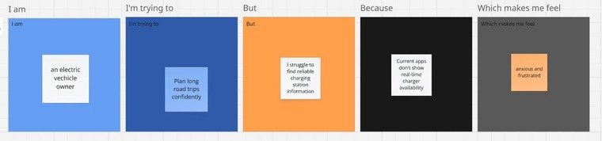
A well-articulated customer problem statement allows you and your team to find the ideal solution for the challenges your customers face. Throughout the process, you’ll also be able to empathize with your customers, which helps you better understand
how
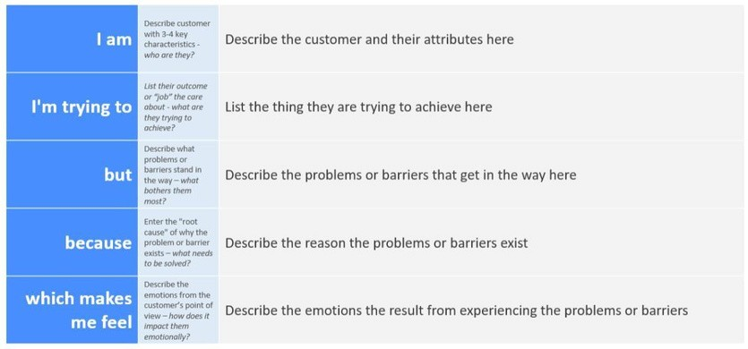
they perceive your product or service.
Reference: https://miro.com/templates/customer-problem-statement/
Example:
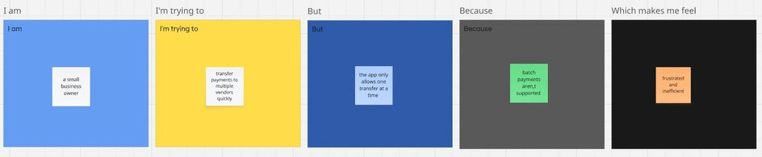
Problem  Statement (PS)  PS-1  PS-2 | I am  (Customer)  An electric vehicle owner  A small business owner | I’m trying to  Plan long road trips confidently  Transfer payments to multiple vendors quickly | But Because  I struggle to Current  find apps don’t reliable show real charging time station charger  information availability  The app ^{Batch}  only allows payments  one are not  transfer at a supported  time | Which makes me feel  Anxious and frustrated  Frustrated and inefficient
2.2 EMpathy map

